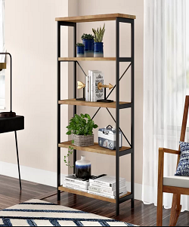

Modern Wall bookcase

$98.78

Availability: In stock

**Description:**

Clean, contemporary design meets rustic industrial style in this étagère bookcase. Crafted of wrought iron in a matte finish, this bookcase features an open, clean-lined rectangular frame complete with an X-frame backing and ladder sides. Rounding out the design, four manufactured wood shelves with laminate veneers in a reclaimed wood finish provide perfect platforms for displaying everything from books, to framed photos, to collected curios.